OTHER EVALUATIONS (*):
Members | Task Details
Member 1 | 15 Questions and Expand - 100%

TASK ASSIGNMENT TABLE:
Content | Result
Average total time to complete the lab (1) | 12 hours
Video Link (2)
(if any)
Feedback (3) (if any)
+ Challenges
+ Suggestions …
Self-Assessment Score (4) | 10/10
(*): Sections (1) and (4) are mandatory.

Teacher: Phan Trung Phát

Name | ID
Trần Anh Tuấn | 24521943

TCP/UDP Protocol
2

Question 1: Through guidance, research, and present the fundamental differences, advantages, and disadvantages of UDP and TCP. Through observing the video streaming, research and present the answers to Q1, 2, 3, 4, 5. Find and complete Q6 to be used as information, contributing to a clearer understanding of DNS and TCP content below

Fundamental Differences between TCP and UDP
Feature | TCP (Transmission Control Protocol) | UDP (User Datagram Protocol)
Connection type | Connection-oriented (requires a 3-way handshake before data transfer). | Connectionless (no handshake, packets sent directly).
Reliability | Reliable – lost packets are retransmitted; sequence numbers and acknowledgments ensure delivery and order. | Unreliable – packets may be lost, duplicated, or arrive out of order; no retransmission.
Flow / Congestion Control | Uses flow and congestion-control algorithms (e.g., sliding window). | No flow or congestion control; sender transmits at constant rate.
Speed | Slower, due to overhead of acknowledgments and error correction. | Faster, minimal overhead.
Data Boundary | Treated as a continuous stream of bytes. | Message-oriented; each datagram remains separate.
Use cases | Web (HTTP/HTTPS), email (SMTP), file transfer (FTP), etc. | Real-time services like VoIP, online games, live video/audio streaming, DNS.

Advantages & Disadvantages
TCP – Advantages
- Reliable, ordered delivery.
- Automatic error detection and recovery.
- Suitable for applications where data integrity matters (web, file transfer).
TCP – Disadvantages
- Higher latency and overhead.
- Inefficient for real-time or delay-sensitive applications.
UDP – Advantages
- Lightweight and fast transmission.
- Lower latency, suitable for real-time communication.
UDP – Disadvantages
- No guarantee of delivery or ordering.
- Must handle reliability at the application layer if needed.

Question | Answer / Explanation
Q1 : *Describe the observed result when streaming via rtsp://…:8554 * | The video played smoothly with minimal delay. Occasional frame drops may occur due to packet loss, but the stream continued without reloading.
Q2 : Which transport protocol was used? | UDP. The Wireshark capture showed UDP packets because RTSP (Real-Time Streaming Protocol) often transmits media over RTP/UDP for low-latency performance.
Q3 : *Describe the result when streaming via http://…:8080 * | The video loaded more slowly and buffered before playback. Playback was smoother once buffered because packets were retransmitted if lost.
Q4 : Which protocol was used? | TCP. The HTTP stream relies on TCP, ensuring reliable delivery but increasing delay.
Q5 : Difference between the two attempts | The UDP stream (rtsp://) prioritized speed over reliability, allowing small data loss for continuous playback. The TCP stream (http://) ensured reliable transmission but introduced buffering and delay. This shows that UDP suits live or real-time streaming, while TCP suits on-demand or file-based streaming.

DNS Information

IPv4 Address | 192.168.100.190 | Local machine address on LAN
Link-local IPv6 Address | fe80::5d2d:a307:da1c:6a2%12 | Auto-configured IPv6 for local communication
MAC Address | 9C-B6-D0-B8-A1-B3 | Physical identifier of network card
Default Gateway | 192.168.100.1 | Router interface used for outbound traffic
DNS Servers | 8.8.8.8 (Google DNS), fe80::1  192.168.100.1 | Servers that translate domain names to IP addresses

This DNS data helps illustrate how UDP and TCP are applied in the real world:
- DNS over UDP: Quick queries (e.g., A record lookups) use UDP port 53 for speed.
- DNS over TCP: Used when responses exceed 512 bytes or for tasks like zone transfers, relying on TCP’s reliability.

Question 2: In the list of captured packets, locate the packet querying the domain uit.edu.vn

Evidence:
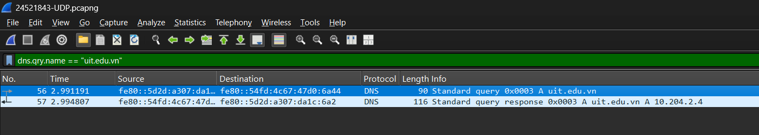

Explanation:
Using the display filter dns.qry.name == "uit.edu.vn", the DNS query and query packet is packet No. 56 represents the standard query for the domain uit.edu.vn.

Question 3: Identify the response packet to the above query? From the response message, record the IP address of the domain uit.edu.vn

Evidence:
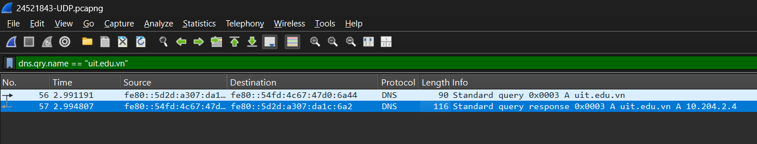

Explanation:
The response packet corresponding to the DNS query for uit.edu.vn is packet No. 57, which labeled “Standard query response 0x0003 A uit.edu.vn”, and from its message details, the IP address returned for the domain is 10.204.2.4. This indicates that the DNS server successfully resolved the hostname uit.edu.vn to its IPv4 address 10.204.2.4.

Question 4: Select one UDP packet, identify the fields present in the UDP header, and explain the significance of each field?

Evidence:
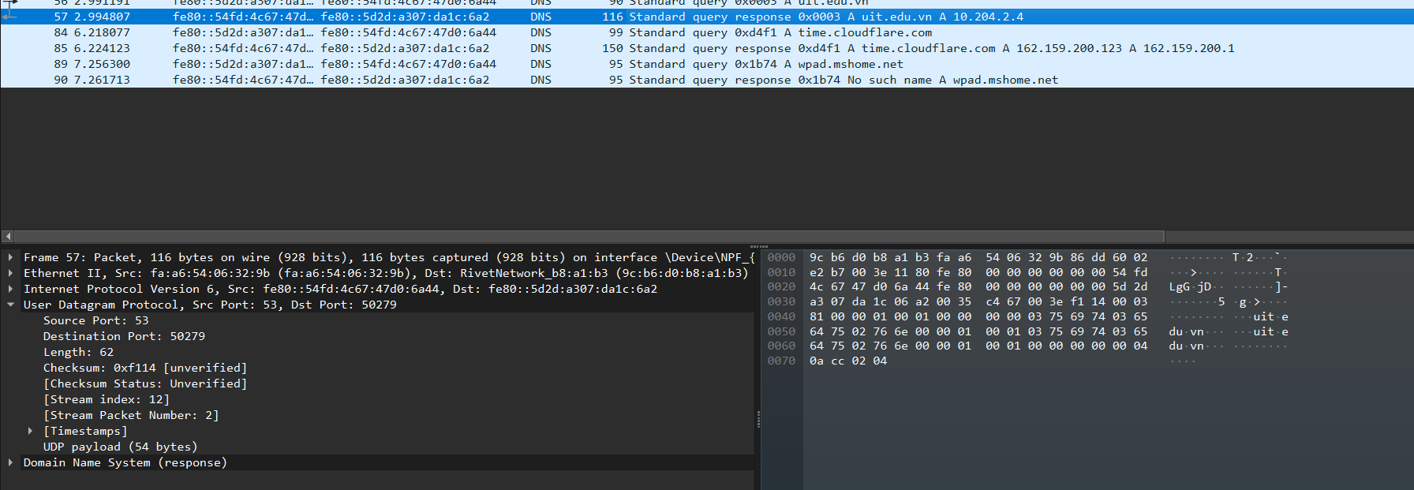

Explanation:
In the selected UDP packet, the header contains four essential fields:
- Source Port: 53
- Destination Port: 50279
- Length: 62 bytes
- Checksum: 0xF114

Question 5: Based on the information displayed in Wireshark, determine the length (in bytes) of each field in the UDP header?

Evidence:
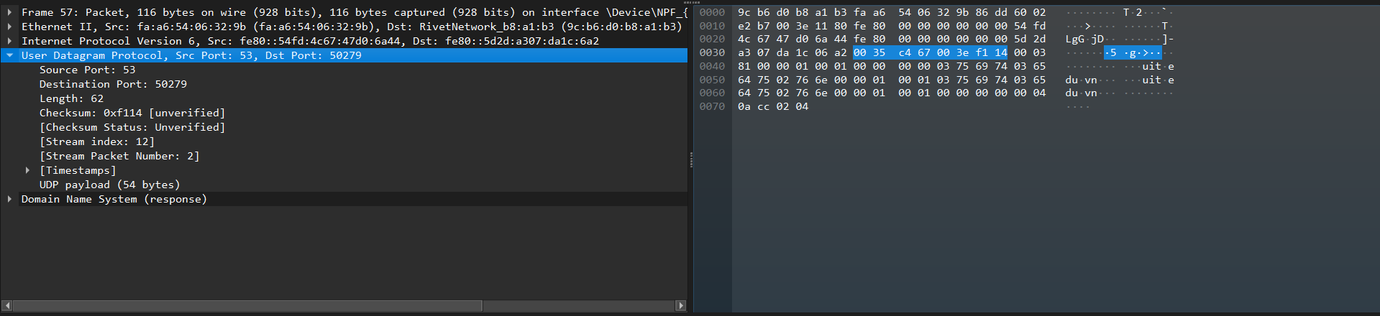

Explanation:
Using packet No.57 as example UDP packet, each field in the UDP header is 2 bytes (16 bits) long, making the total UDP header size 8 bytes. Wireshark confirms this when you expand the “User Datagram Protocol” section and examine the byte positions in the Hex view.

Question 6: What does the value of the Length field in the UDP header represent the length of? Provide evidence to support this claim.

Evidence:
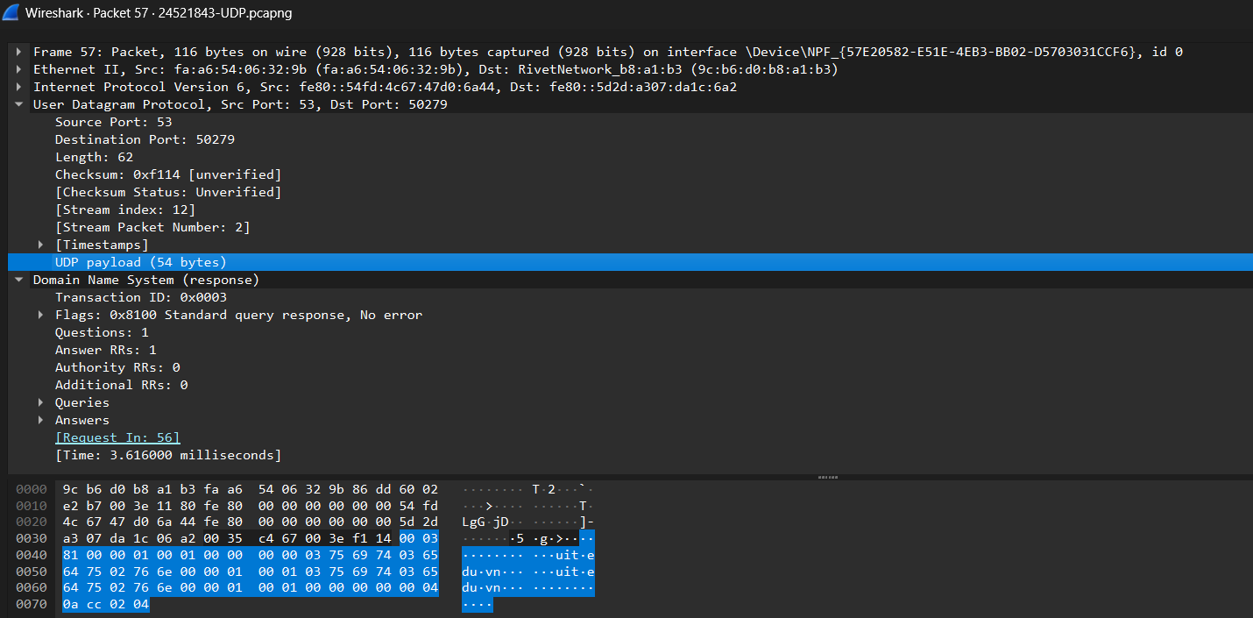

Explanation:
In packet No. 57, the UDP Length field = 0x003e, which equals 62 bytes in decimal. According to the UDP protocol specification, this value represents the total length of the UDP segment, including:

- The UDP header (8 bytes)
- The UDP data payload (54 bytes)
This can be verified in Wireshark, where the packet detail shows:
Length: 62
UDP payload (54 bytes)
Thus,
62 – 8 = 54 bytes, which exactly matches the data size displayed under the “UDP payload” section.

Question 7: What is the maximum number of bytes that the UDP payload (the section containing the original data, excluding the UDP header and IP header) can contain?

Evidence:
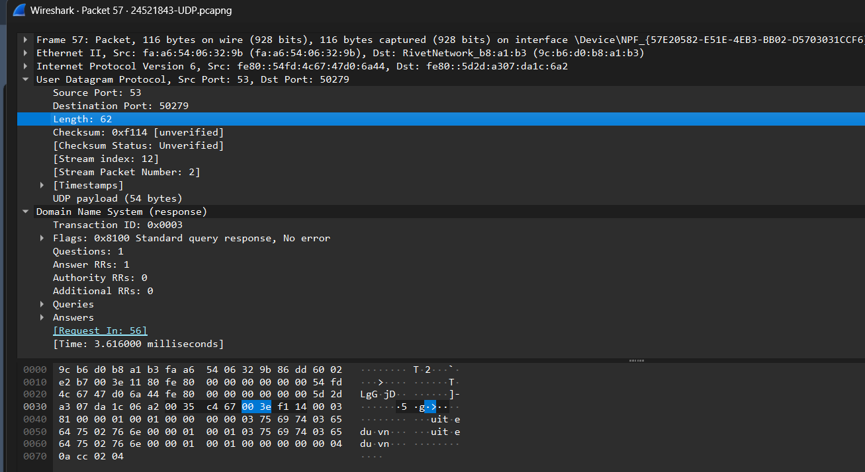

Explanation:
Each field in the UDP header is 2 bytes (16 bits) long, including the Length field.
Since this field is 16 bits, its maximum hexadecimal value would be: 0xFFFF = 65,535 (decimal). If the Length field could reach its maximum value (65,535), and the UDP header is 8 bytes, then: "Maximum payload" = 65,535 – 8 = 65,527 bytes

Question 8: What is the maximum possible value for the Source port?

Evidence:
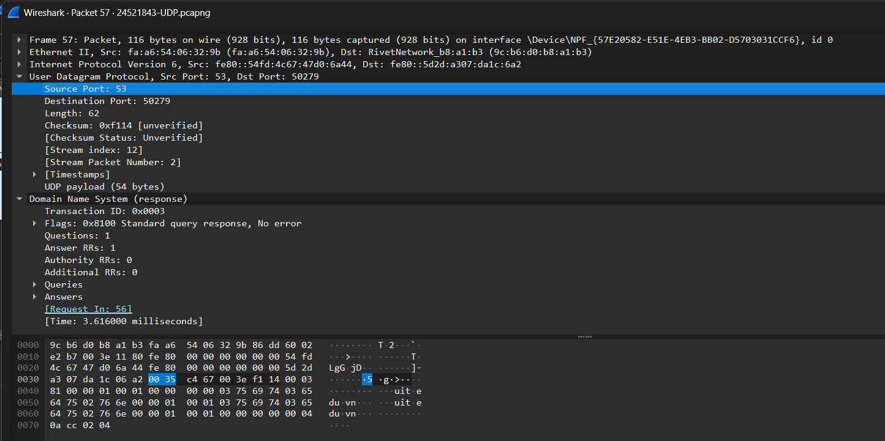

Explanation:
The Source Port field in the UDP header is 16 bits long (2 bytes).
Because a 16-bit number can represent values from 0 to 65,535 (2¹⁶ − 1), the maximum possible value for the Source Port is: 65,535
​

Question 9: Observe the two packets found in 2. and 3., and describe the relationship between the IP addresses and ports of these two packets.

Evidence:
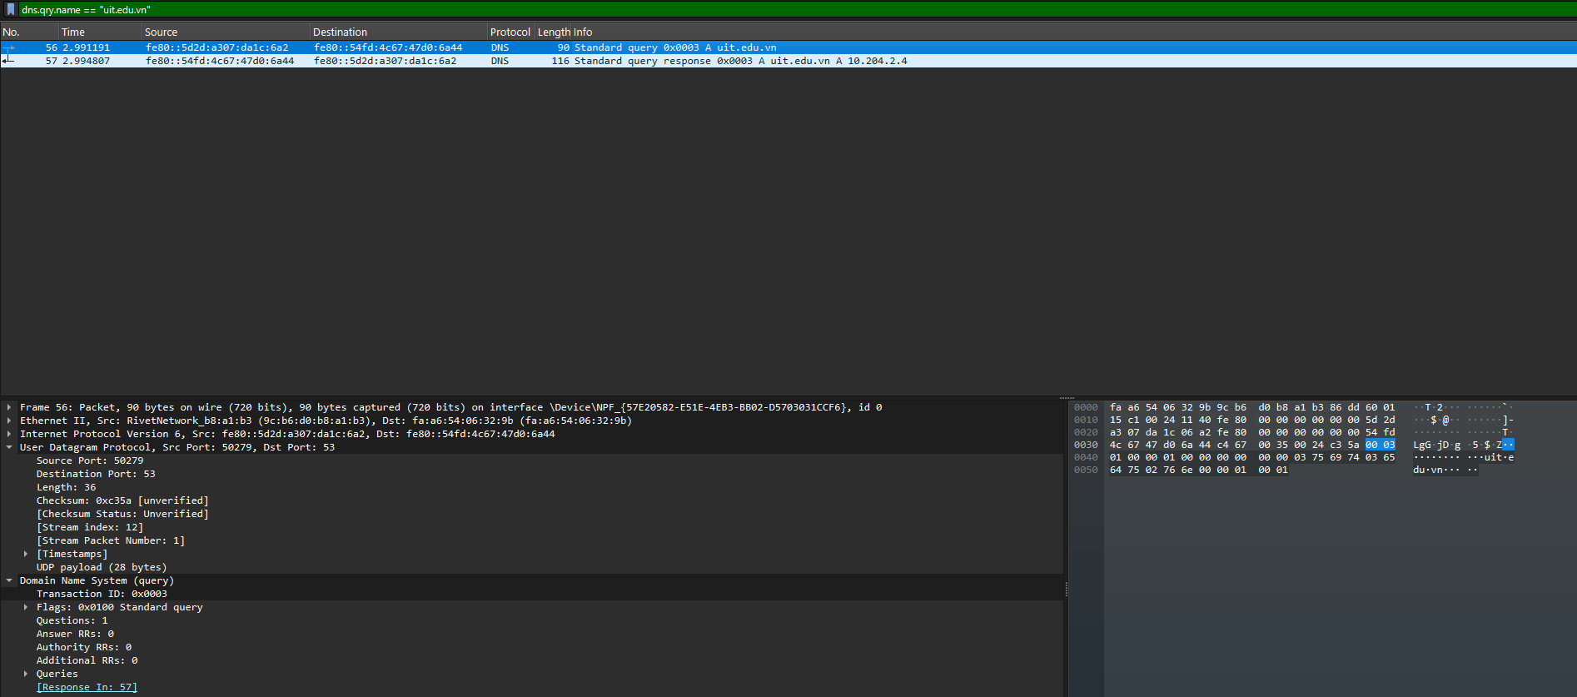
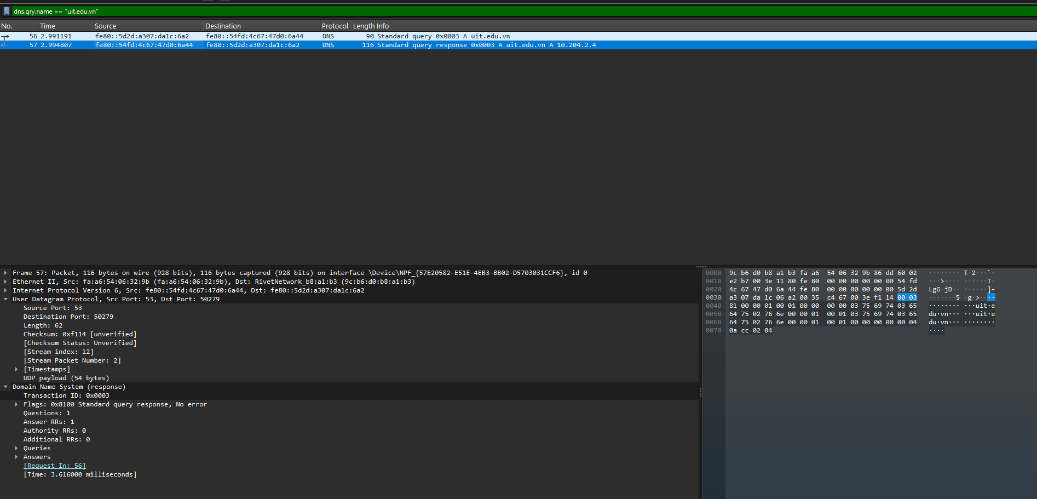

Explanation:
In Packet 56 and Packet 57, the IP addresses and ports are reversed between the query and response. The client (fe80:5d2d:a307:da1c:6a2, port 50279) sends the query to the DNS server (fe80::54fd:4c67:47d0;6a44, port 53), and the server replies from port 53 back to the client’s port 50279. This confirms a request–response relationship typical of DNS over UDP.

Question 10: Find the IP address and TCP port of the Client machine?

Evidence:

Explanation:
In the TCP session shown, the client machine has the IP address 192.168.100.190 (show in Internet Protocol Src) and uses the source port 55640 (show in Transmission Control Protocol Src Port) to communicate with the web server.

Question 11: Find the IP address of the Server. Which port does it use to receive segments?

Evidence:

Explanation:
In the TCP session shown, the web server has the IP address 118.69.123.140 (show in Internet Protocol Dst) and listens on the standard HTTP port 80 (show in Transmission Control Protocol Dst Port) to receive incoming segments.

Question 12: Locate the TCP SYN segment (TCP packet with the SYN flag set) that initiates the TCP connection between the client and the server. Which component in the segment indicates that it is a TCP SYN segment?

Evidence:
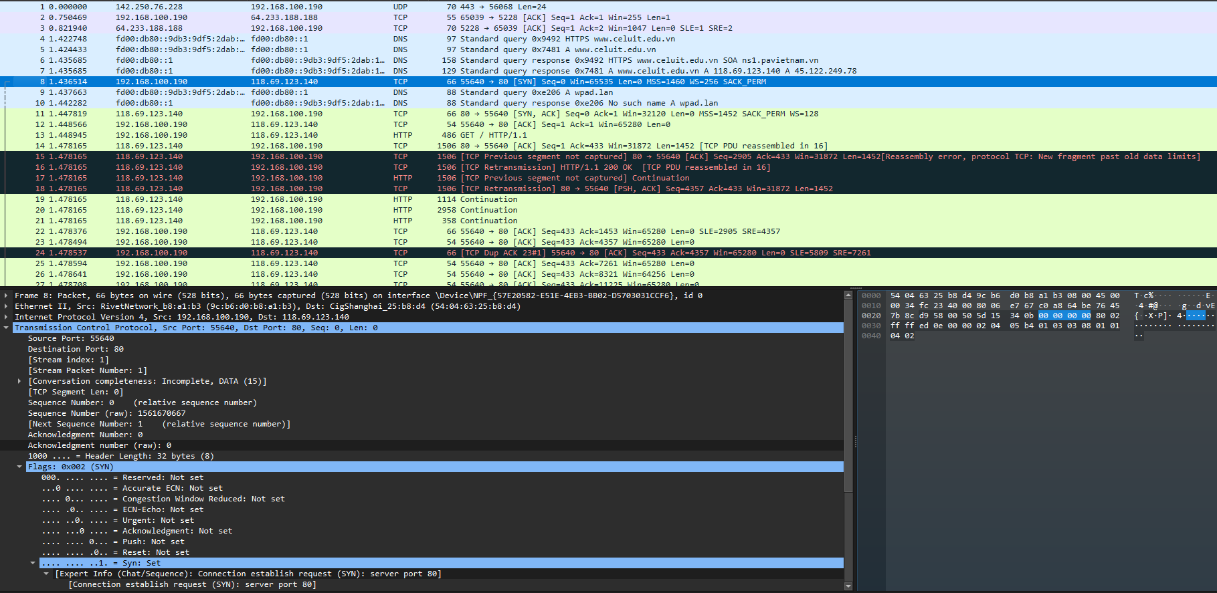

Explanation:
In your Wireshark screenshot, under Transmission Control Protocol, you can see the following line: .... .... .... ..1. = Syn: Set
This means:
- The SYN flag is set to 1 (ON).
- All other control flags (ACK, FIN, RST, PSH, URG) are 0 (OFF).
Wireshark explicitly shows this as Flags: 0x002 (SYN) and Syn: Set, confirming that this packet initiates the TCP connection.

Question 13: Find the sequence number of the SYN/ACK segment sent by the server to the client in response to the SYN segment.
Find the value of the Acknowledgement in the SYN/ACK segment.
How can the server determine this value? Which component in the segment indicates that it is a SYN/ACK segment?

Evidence:
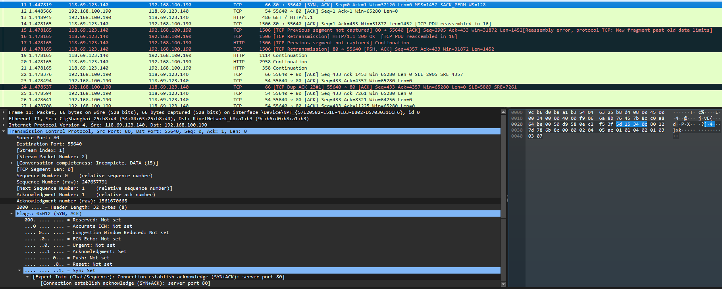

Explanation:
In the Wireshark details pane, you can see:
- Sequence Number: 0 (relative sequence number)
- Acknowledgment number: 1 (relative ack number)
The server determines this acknowledgment value as follows:
- Initially, the client sends a SYN segment with a Sequence Number = 0.
- When the server receives this SYN, it creates a SYN/ACK segment in reply.
- The Acknowledgment Number in the SYN/ACK is calculated as the client’s Sequence Number + 1.
In this case, Acknowledgment = 0 + 1 = 1, meaning the server successfully received the client’s SYN and is acknowledging it.
- For the following ACK packet from the client, the acknowledgment number is also derived as previous Sequence Number + 1 (so here, ACK = 1).
In the Flags field, both the SYN and ACK flags are set to 1, which indicates that this packet is a SYN/ACK segment.

Question 14: Identify the first 6 segments that the server sends to the Client

Evidence:
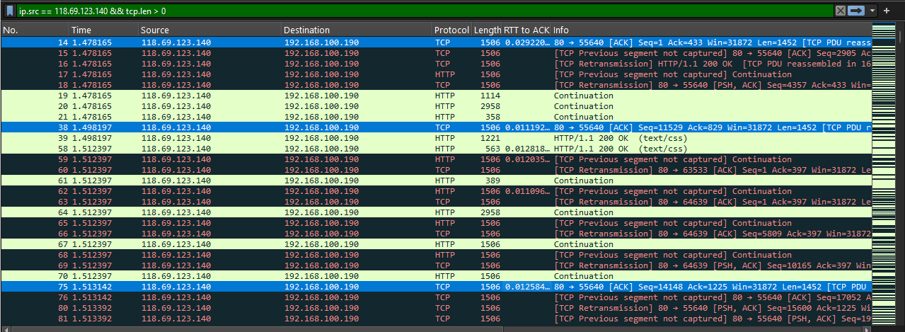
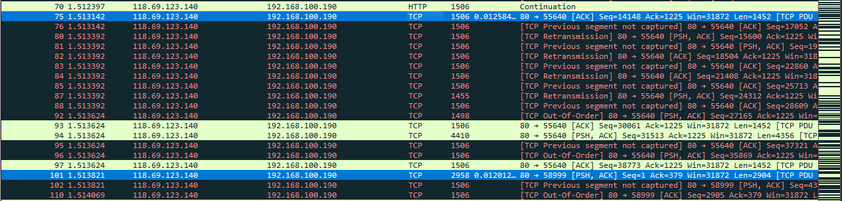
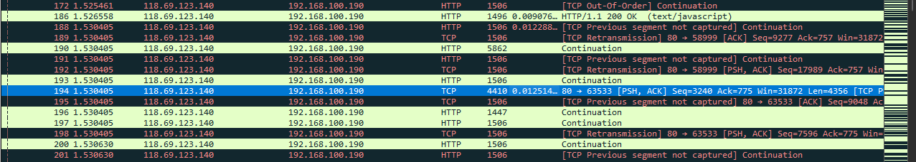

Explanation:
No. | Time | RTT (ms) | SEQ number | ACK number | Classification
14 | 1.478165 | 29.220 | 1 | 433 | ACK
38 | 1.498197 | 11.192 | 11529 | 829 | ACK
75 | 1.513142 | 12.584 | 14148 | 1225 | ACK
101 | 1.513821 | 12.012 | 1 | 379 | ACK
194 | 1.530405 | 12.514 | 3240 | 775 | PSH, ACK
315 | 1.569930 | 13.901 | 100350 | 2073 | ACK

Question 15: Was any segment retransmitted? What information during the transmission process indicates this? Provide an explanation.

Evidence:
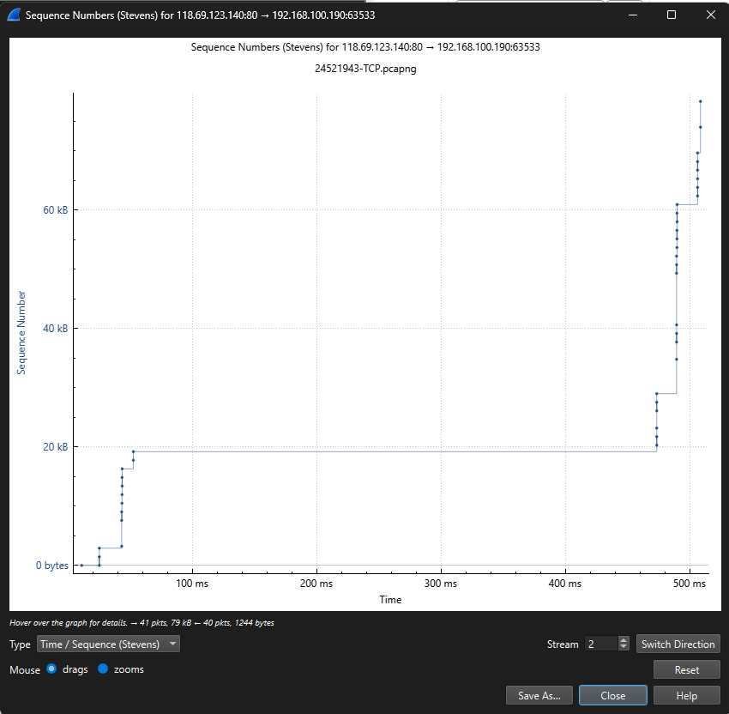
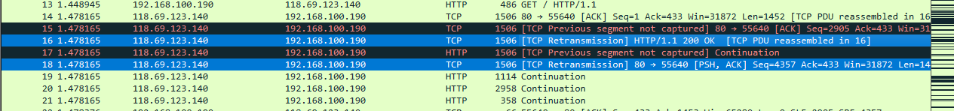

Explanation:
Yes, retransmissions occurred during the TCP connection.
This is shown by overlapping sequence numbers in the Time–Sequence (Stevens) graph, where the same data bytes are resent at later times. In Wireshark, retransmitted packets are marked with the label “[TCP Retransmission]” or “[Out-of-Order]”, confirming that the sender resent segments due to missing or delayed acknowledgments. This behavior indicates packet loss or acknowledgment delay in the network.

END

